**ENTERPRISE & CLOUD SECURITY. PERSPECTIVES FOR 2023 & BEYOND**

**Data Theft & Breaches in the U.S.**

|  |  |
| --- | --- |
| **Year** | **Number of Data Breaches** |
| 2015 | 772 |
| 2017 | 1474 |
| 2019 | 1266 |
| 2021 | 1941 |
| 2023 | 2989 |

**Rising Average Cost Per Data Breach ($ Million)**

|  |  |
| --- | --- |
| **Year** | **Cost Per Breach (In US$ Million)** |
| 2015 | 3.2 |
| 2017 | 3.6 |
| 2019 | 3.9 |
| 2021 | 4.4 |
| 2023 | 5.6 |

**Cloud Security Global Revenues ($ Billion)**

|  |  |
| --- | --- |
| **Year** | **Market Size** |
| 2022 | 36.8 |
| 2024 | 50.4 |
| 2026 | 67.3 |
| 2028 | 88.1 |
| 2030 | 113.3 |

**User Provisioning, the Largest Policy Implementation in Cloud IAM**

|  |  |
| --- | --- |
| **Segment** | **% Share** |
| User Provisioning | 42.6 |
| Single Sign-on | 16.8 |
| Governance & Compliance Management | 12.5 |
| Multi-Factor Authentication | 10.4 |
| Access Management | 7.8 |
| Others | 10.0 |
| **Total** | **100.0** |

***Note: All the 4 table charts above give in one row in the infograph***

**2023 Essential Facts**

*(Present the following according to the image given below with the numbers inside the circle)*

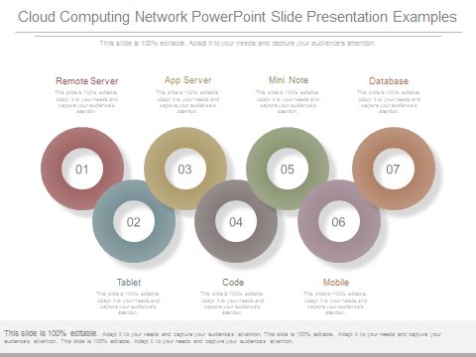

**82%** of personal information of the world's population will be protected by data privacy laws by 2025

**90%** reduction in financial costs of security incidents can be achieved by deploying cybersecurity network architecture

**30%** of enterprises by 2025 will deploy SWG, CASB, ZTNA & FWaaS from a single vendor highlighting the trend towards vendor consolidation

**45%** of corporate boards by 2025 will have a dedicated cybersecurity committee

**76%** of CEOs believe in building a culture of corporate resilience to survive threats from cybercrime

**90%** of security breaches are targeted at servers

**18%** of security breaches is due to cloud misconfigurations

**79%** of critical infrastructure organizations do not deploy Zero Trust security architecture, raising the risk of breach to $1 million

**Are You Ready for These Trends?**

*(present the data in the sample image copied below)*

IT/OT Convergence & Cybersecurity Gaps in Manufacturing Industry

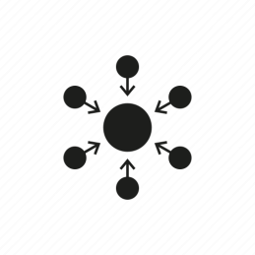

Outsourcing of Cybersecurity Operations



Threat of “Shadow Cloud” & Role of CASBs

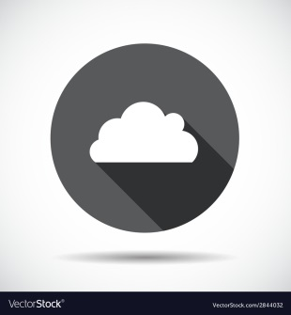

Development of Quantum-Safe Certificates



Rise of Multifactor Authentication (MFA)

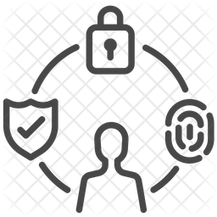

IoT & 5G, a Turning Point in Technology & Risks



Zero Trust Initiatives

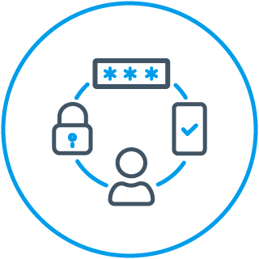

Rise of Artificial Intelligence (AI) in Cybersecurity



Growing popularity of Optical Encryption & Quantum Cryptography

